Mohamed Husain Abdulla Mahdi Ali

202101911 | Bahrain polytechnic

Project Report

IT7405

Contents

Brief 2

The Process 2

Screenshots 3

Challenges Faced 8

Lessons Learned 8

# Brief

The aim of the project is to make website that fit the needs of the application we wrote in the excel spread sheet that were given to us by the tutor.

(Diving and Vehicle Rental):

The Aim of the website is to provide licensed divers the equipment they need by renting them.

# The Process

First step is to create an Anaconda Prombt Environnment to contain the whole pip applications needed for the project.

Second step is to create a Django program, from there we start by starting the application.

Then the making of the base html.

Then the models

Then the forms

Then the views

Then the urls

Then the templates.

Third is step to making the migrations in addition to migrate and finally running the server.

# Screenshots

Home Page:

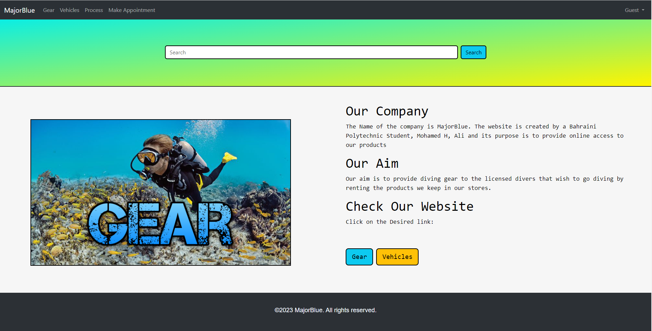

Gear Page:  
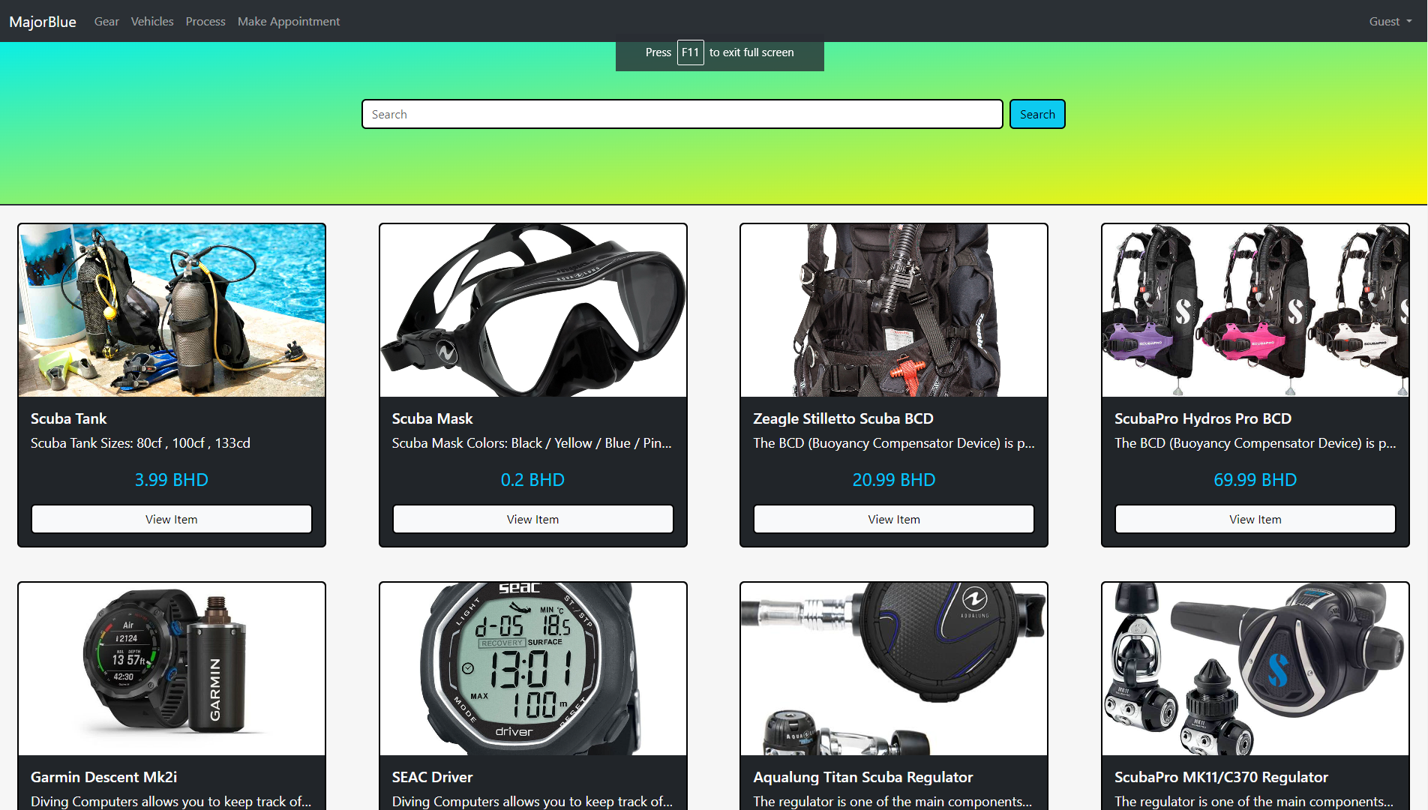

Vehicle Page:

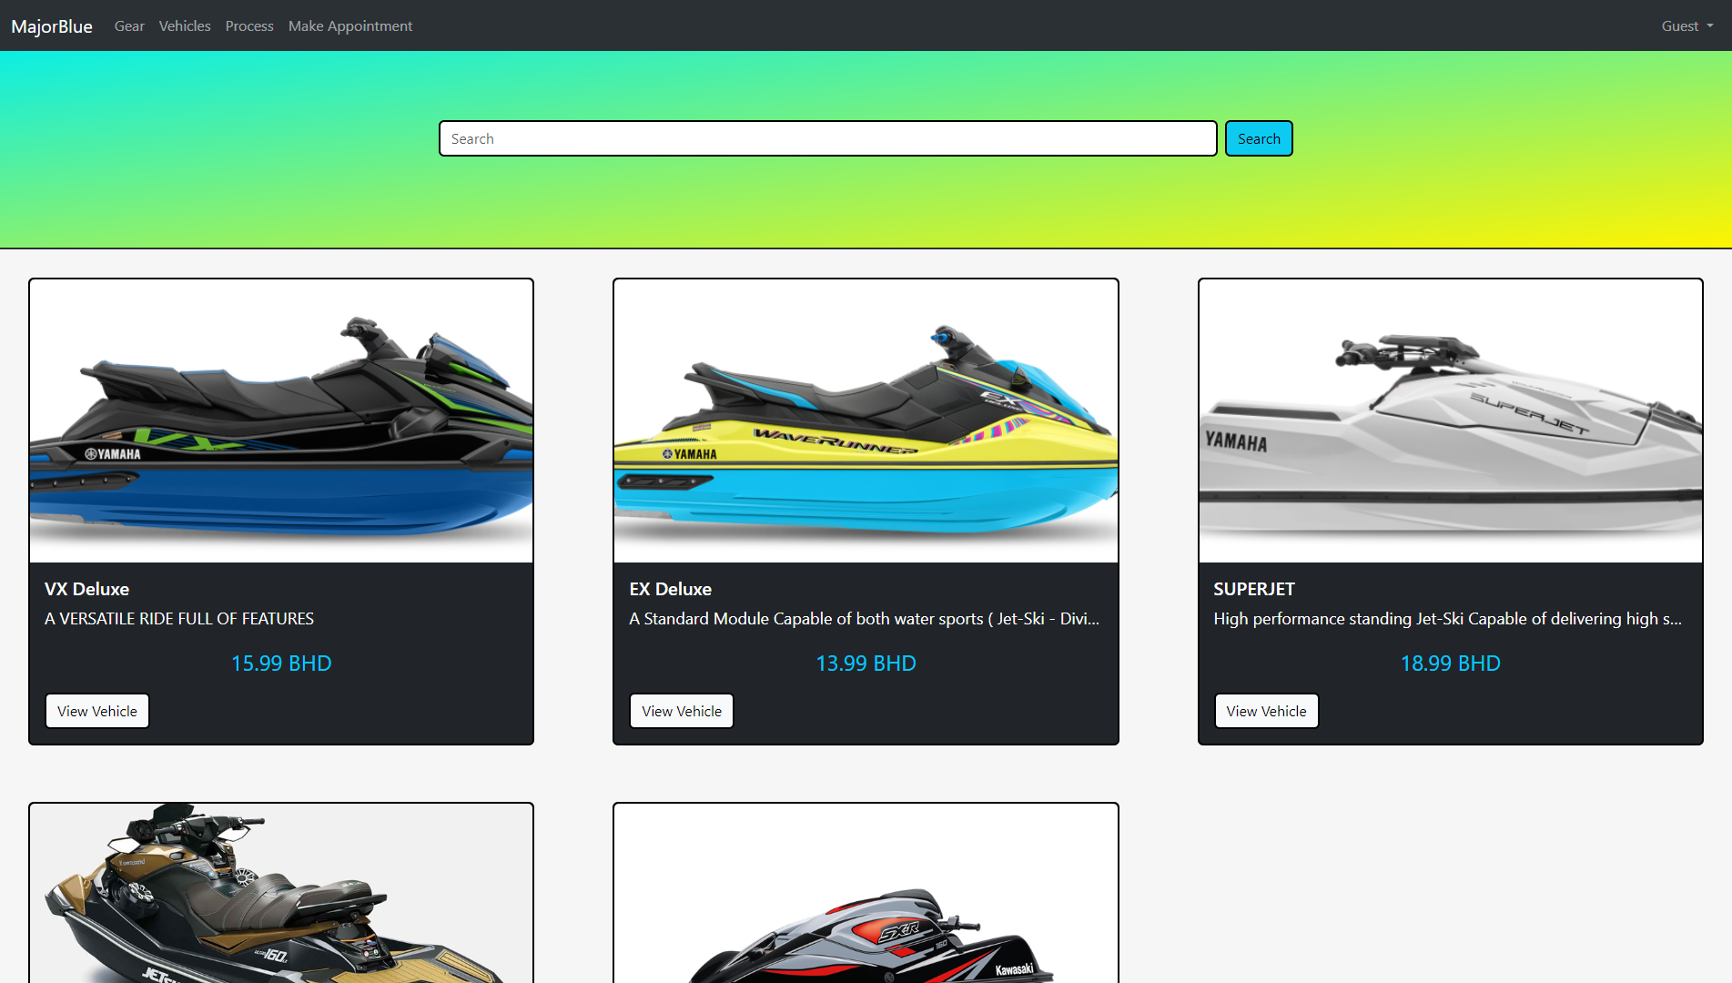

Footer:

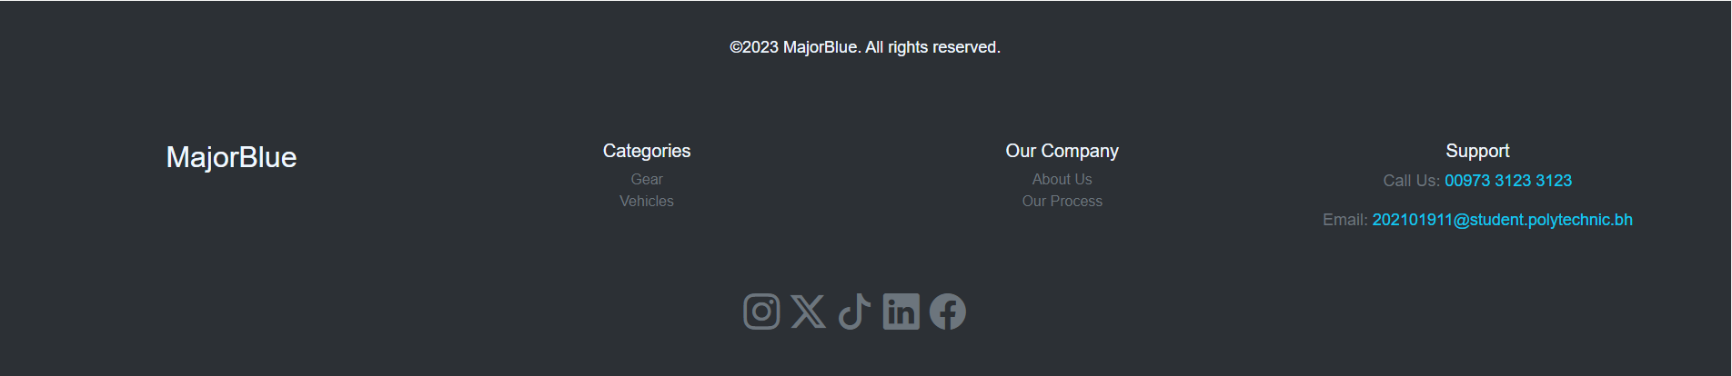

Gear Details Page:

Vehicle Details Page:

Register Page:

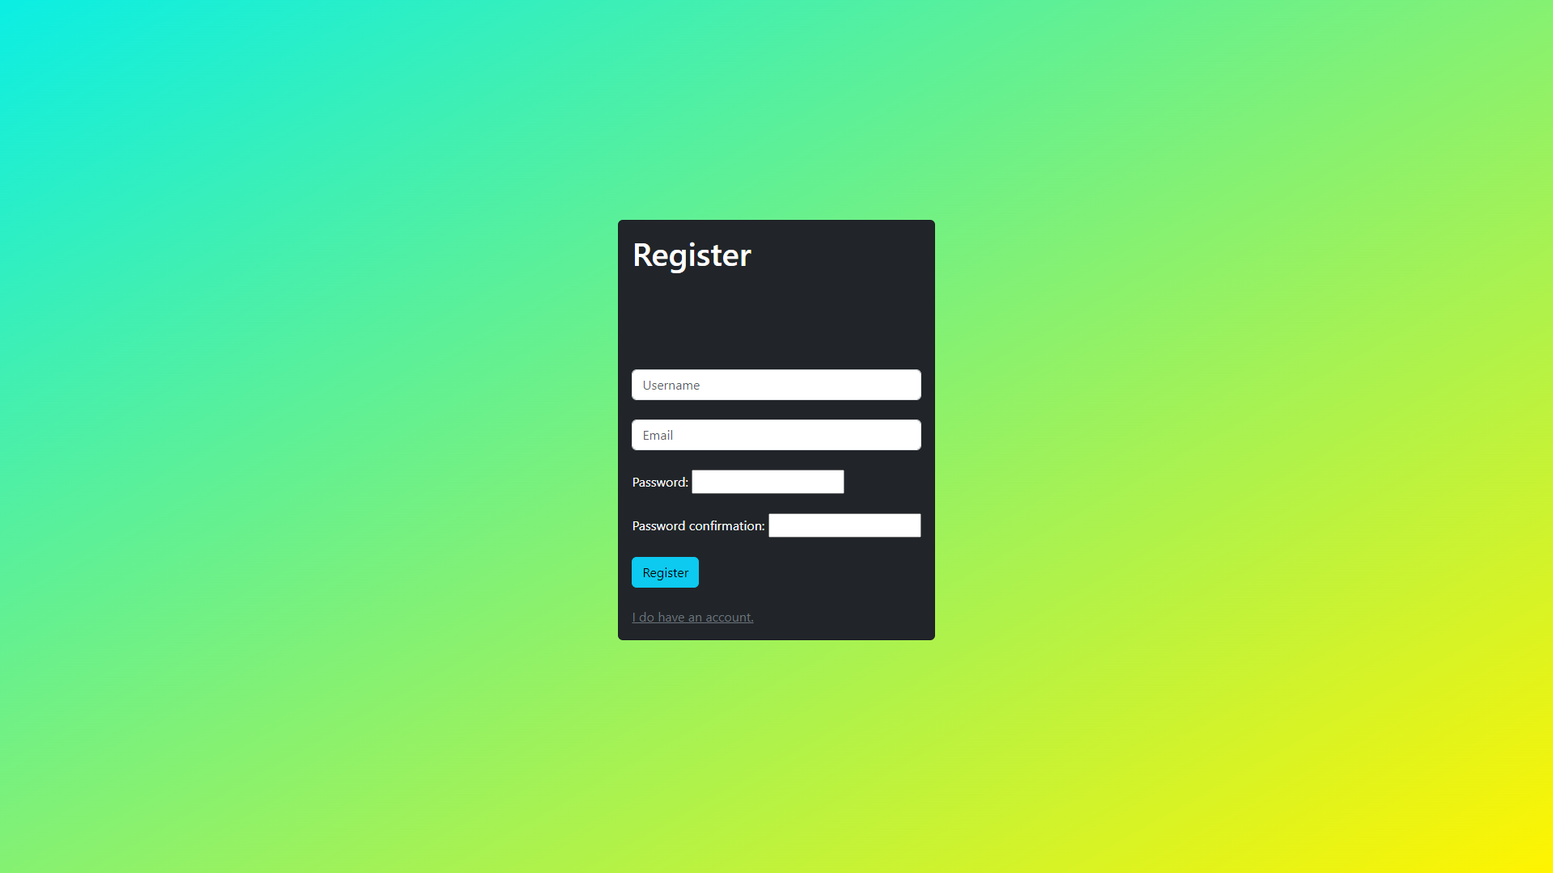

Login Page:

Make Appointment Form:  
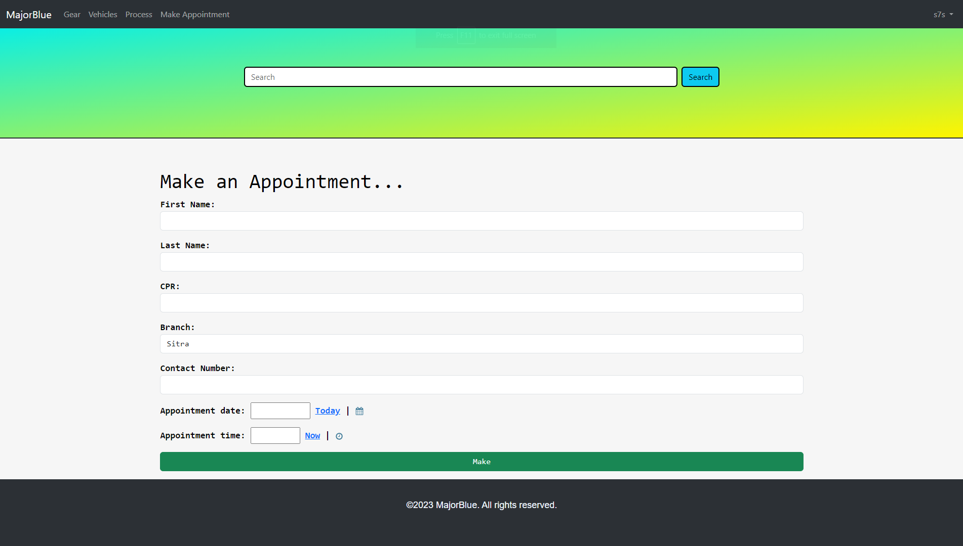

Appointments Page:

# Challenges Faced

First Challenge:

Dealing with models was a bit hard since I needed to make migrations after every successful change. However when I wanted to edit an existing model errors will show up and I need to delete the 0001_init file and it will work.

Second Challenge:

Keeping track of every code.

# Lessons Learned

Learned:

* How to make a website using Django.
* Learned how to use MongoDB and integrate it into Django.
* Learned how to use python and use it in Django.